METACHRONOUS SQUAMOUS CELL CARCINOMA IN ALBINISM: DIAGNOSTIC AND MANAGEMENT CHALLENGES IN A RESOURCE-LIMITED SETTING, A CASE REPORT

Elizabeth Msangi^{1,2}, Silas Frank Gamba¹, Evelyna Gasper¹, Emmanuel Lusomi¹, Halima O. Suleimani¹, Deogratias Mwanjamila³

¹Department of Internal Medicine, Muhimbili University of Health and Allied Sciences, Dar es Salaam, Tanzania
²Department of Dermatology, Muhimbili National Hospital, Dar es Salaam, Tanzania
³Department of Pathology, Muhimbili University of Health and Allied Sciences, Dar es Salaam, Tanzania
Corresponding author: Evelyna Gasper; evegasper21@gmail.com

ABSTRACT
Background: Oculocutaneous albinism (OCA) encompasses a group of autosomal recessive disorders characterized by defective melanin biosynthesis, which confers a markedly increased susceptibility to ultraviolet (UV)-related skin damage and keratinocyte carcinomas . In sub-Saharan Africa (SSA), squamous cell carcinoma (SCC) is the predominant histological skin cancer reported in people with albinism. Affected individuals face a disproportionate burden of multiple, concurrent malignancies, making early recognition, definitive treatment, and long-term surveillance particularly important especially in settings where advanced margin-controlled surgical techniques and molecular testing are unavailable.
Case presentation: A 48-year-old Tanzanian woman with OCA and prolonged occupational sun exposure presented with a 3-year history of progressive cutaneous lesions on sun-exposed areas and a 5-month history of a non-healing ulcerative lesion on the right neck, superimposed on a background of extensive actinic keratosis. Three years earlier, she had undergone a right orbital exenteration for an eyelid SCC; histopathology at the time showed perineural invasion and involved surgical margins, which was followed by adjuvant chemotherapy and external-beam radiotherapy. Recent histopathological evaluation of the new right neck lesion demonstrated an invasive SCC with cytological atypia identical to the prior eyelid tumor, highlighting the phenomena of severe field cancerization and metachronous tumor development.
Conclusion: In people with OCA, a previous SCC should prompt lifelong, comprehensive skin surveillance rather than lesion-focused follow-up. The diagnostic complexity posed by synchronous and metachronous tumors in field-cancerized skin requires careful histopathological characterization, as clinical and dermoscopic appearances may not reliably predict tumor lineage. While surgical excision remains the first-line treatment for most localized cutaneous SCC, this case underscores the urgent need for structured photoprotection programs, early assessment of new lesions, and the establishment of robust multidisciplinary cancer care pathways for persons with albinism in Tanzania and across SSA.

Keywords: Oculocutaneous albinism; Squamous cell carcinoma; Field cancerization; Synchronous tumors; Metachronous tumors; Tanzania; Sub-Saharan Africa.

INTRODUCTION

Oculocutaneous albinism (OCA) encompasses a heterogeneous group of autosomal recessive disorders characterized by the marked reduction or absence of melanin (Fernández, Hayashi and Montoliu, 2021). Because melanin serves as the primary photoprotective pigment, its deficiency renders the epidermis profoundly vulnerable to ultraviolet (UV)-induced DNA damage and subsequent keratinocyte carcinomas. Sub-Saharan Africa bears a uniquely high burden of albinism; prevalence rates reach 1:1,000 in some populations, with Tanzania ranking among the highest-burden countries globally (Kromberg et al., 2022). Affected individuals in this region face compounding disadvantages, including intense equatorial UV exposure, lack of photoprotection, and inadequate dermatologic surveillance. Consequently, this population suffers a devastating excess of early-onset skin malignancies, with squamous cell carcinoma (SCC) predominating (Kiprono, Chaula and Beltraminelli, 2014).

We report the case of a 48-year-old Tanzanian woman with OCA who developed a second, anatomically distinct cutaneous SCC three years after a right eyelid SCC that was treated with orbital exenteration and adjuvant chemoradiotherapy. Notably, her prior eyelid SCC featured incomplete surgical margins. The current lesion was clinically suspected to be a basal cell carcinoma but was definitively confirmed on histopathology as an SCC, superimposed on extensive field cancerization (Slaughter, Southwick and Smejkal, 1953). The co-occurrence of multiple keratinocyte carcinomas; whether developing simultaneously (synchronous) or sequentially (metachronous) is a recognized but insufficiently documented phenomenon in the East African setting. This presentation exemplifies the cumulative carcinogenic effect of chronic UV exposure and the severe risks associated with incomplete surgical margins in high-risk anatomical zones.

CASE PRESENTATION

A 48-year-old Tanzanian woman with OCA, a subsistence farmer, presented to the dermatology outpatient clinic at our tertiary facility. She reported inconsistent photoprotection practices with no established routine of dermatological surveillance representing a typical socioeconomic profile of at-risk PWA. She had no reported history of cigarette smoking, alcohol use, and an HIV test performed two months prior was negative.

She had a 3-year history of multiple progressive cutaneous lesions involving sun-exposed areas of the face, neck, and bilateral upper and lower extremities. Lesions began as small brown papules with pruritus and scaling, steadily increasing in number and surface area. Over the preceding five months, a lesion on her neck had become indurated and subsequently ulcerated. She denied any active bleeding or discharge from the lesions, or constitutional symptoms. Her oncological history was notable for a right-sided ocular malignancy diagnosed 3 years prior. Orbital exenteration was done, and histopathological examination of the exenterated eyelid specimen confirmed squamous cell carcinoma (SCC) with perineural invasion and involved (positive) surgical resection margins (Figure 1). This was followed by four cycles of chemotherapy and external-beam radiotherapy as adjuvant therapy. While she was placed on annual follow-up, there was no post-treatment cross-sectional imaging or margin re-excision due to social constraints.

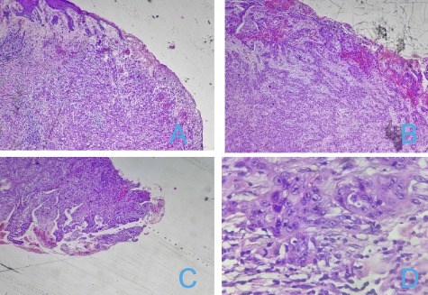
Figure 1. Exenteration specimen showing eyelid SCC with stromal invasion and inflammatory response (A, B), a tumour-positive margin (C), and high-power view of pleomorphic, hyperchromatic squamous cells with increased N ratio and prominent nucleoli (D).

On physical examination, she exhibited classical features of OCA, including straw-coloured hair, hypopigmented eyebrows, yellowish-orange irides, and left-eye rotary nystagmus. The right orbital cavity was well healed following the previous exenteration. Examination of the integumentary system revealed coarse wrinkling with a leathery, mottled texture at the nape of the neck, consistent with chronic actinic damage and solar elastosis. Multiple rough, scaly erythematous papules with indurated hyperkeratotic plaques were distributed across the face and the extensor surfaces of bilateral upper and lower limbs, in keeping with extensive actinic keratoses (AK) and field cancerization. An indurated, 2 × 2 cm ulcerated lesion was identified on the left lower cheek, presenting with an irregular margin, rolled border, erythematous base, and firm, non-tender, mobile consistency. A nearby satellite plaque showed crusting and surrounding erythema. Dermoscopy of the ulcer demonstrated central ulceration with a moist pink base, yellow-amber serous crust at the periphery, arborising vessels with pinpoint hemorrhages, and shiny white structures (Figure 2). These features initially favored a clinical diagnosis of nodular basal cell carcinoma. Systemic examinations were otherwise unremarkable.

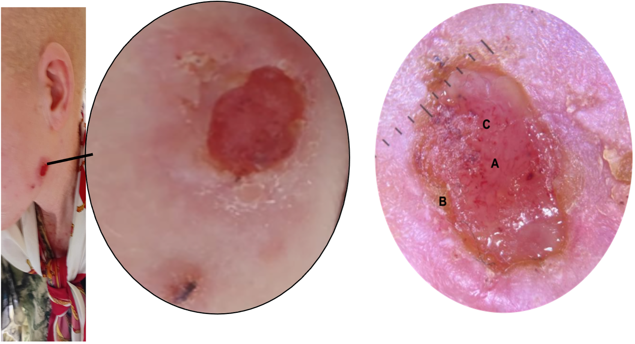
Figure 2. Clinical and dermoscopic features of the ulcerated lesion on the left lower cheek, showing (A) central ulceration with a moist pink stroma, (B) yellow-amber serous crust at the periphery, and (C) arborising vessels with pinpoint haemorrhages.

INVESTIGATIONS

Routine laboratory investigations revealed a mild anaemia with a haemoglobin of 12.98 g/dL (reference 13.0–17.0 g/dL). White blood cell (4.619 K/µL) and platelet (296.6 K/µL) counts were unremarkable. Renal function was preserved, with a creatinine concentration of 72.6 µmol/L (reference 63.6–110.6 µmol/L). Coagulation studies, lipid profiles, and a random blood glucose (6.1 mmol/L) were all within normal limits. A biopsy of new lesion and Histopathological assessment definitively established the diagnosis of invasive SCC, overturning the initial clinical suspicion of basal cell carcinoma. Low-power sections showed keratinized stratified squamous epithelium with nests of tumor infiltrating the underlying stroma, associated with clear keratin pearl formation. High-power examination demonstrated atypical polygonal squamous cells with intercellular bridges definitively excluding BCC (Figure 3). Mirroring the prior eyelid tumor biopsy, these cells were hyperchromatic and pleomorphic, displaying an increased N:C ratio, vesicular chromatin, and prominent nucleoli. Given the anatomically distinct site, a diagnosis metachronous a de novo, second primary SCC was established given the patient's profound risks, though the identical cytological atypia and history of involved surgical margins make locoregional recurrence a critical clinical consideration.

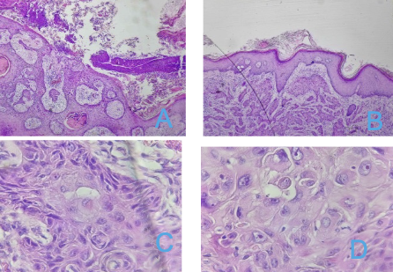
Figure 3. Histological sections of the right neck lesion showing invasive SCC with keratinised stratified squamous epithelium, tumour nests infiltrating the stroma and keratin pearls (A, B); high-power views showing pleomorphic, hyperchromatic polygonal cells with intercellular bridges, increased N ratio, vesicular chromatin and prominent nucleoli (C, D).

TREATMENT

Because Mohs micrographic surgery is unavailable in our setting, the current cutaneous squamous cell carcinoma was managed with standard surgical excision using a 6 mm peripheral margin, and the margins of all excised tissues were confirmed to be free of malignancy. The patient had an unremarkable postoperative course, and at the time of discharge, her surgical wounds were healthy and healing. Liquid nitrogen cryotherapy was administered to address the surrounding actinic keratosis burden, and she received counseling on the necessity of sun protection and close surveillance. To resolve potential residual periorbital disease from the previous positive-margin excision, diagnostic magnetic resonance imaging (MRI) of the orbits and a formal ophthalmological review were specifically planned during her discharge.

DISCUSSION

Cutaneous malignancy is a major complication of oculocutaneous albinism (OCA), particularly in sub-Saharan Africa, where reduced melanin-mediated photoprotection compounds high cumulative ultraviolet (UV) exposure. Squamous cell carcinoma (SCC) predominates among reported skin malignancies in African individuals with albinism. A systematic review and meta-analysis of 23 studies involving 540 individuals with albinism and 695 histologically confirmed skin-cancer lesions identified 419 SCCs and 249 basal cell carcinomas (BCCs); the pooled proportion was 64% (95% CI 50–77%) for SCC versus 31% (95% CI 19–45%) for BCC, with substantial heterogeneity (I² = 89%) (Onyishi and Ohayi, 2022). Our case reflects this pattern, with a second histologically confirmed SCC arising in a patient with extensive actinic damage and a previous high-risk periocular SCC.

However, the lesion also illustrates the limitations of clinical diagnosis: ulceration, a rolled border and arborising vessels suggested BCC, whereas histopathology demonstrated invasive SCC with atypical squamous nests, keratin pearls and intercellular bridges. This distinction is clinically important because SCC and BCC differ in biological behaviour, risk stratification and treatment. Although arborising vessels strongly suggest BCC, they are not pathognomonic; clinical and dermoscopic findings should therefore guide, rather than replace, histopathological diagnosis (Ryu et al., 2018). In patients with OCA, particularly those with previous skin cancer and extensive actinic damage, a low threshold for biopsy of suspicious or atypical lesions is warranted.

This case also illustrates the therapeutic challenges of managing metachronous cutaneous squamous cell carcinomas (SCCs) in a patient with oculocutaneous albinism (OCA) in a resource-limited setting. The extensive actinic keratoses observed in this patient provide clear clinical evidence of a chronically UV-damaged field. Field cancerization describes the accumulation of genetically altered keratinocyte clones within chronically exposed tissue, establishing a biological substrate from which multiple independent malignancies arise (Slaughter, Southwick and Smejkal, 1953). In this clinical context, the emergence of a second SCC at a separate anatomical site represents a metachronous primary tumor rather than local recurrence of the previous eyelid lesion, given the absence of evidence demonstrating anatomical continuity.

The previous eyelid tumour was high risk because of perineural invasion and involved surgical margins. Positive margins in this anatomical site elevate local recurrence rates of up to 30%–50%, compared to clear margins (Keohane et al., 2021). Margin-controlled surgery would have provided an advantage in defining tumour clearance but is not universally available in resource-limited settings (Leibovitch et al., 2005; Alam et al., 2018). Although adjuvant external beam radiotherapy was administered, it remains an imperfect substitute for histologically clear surgical margins. This, and lack of post-treatment cross-sectional imaging highlights a critical vulnerability in monitoring subclinical locoregional disease and is associated with increased risk of adverse outcomes. Consequently, the subsequent SCC developed in an individual whose underlying oncogenic risk remained active despite treatment of the original tumour. Clinicians must adopt a whole-body oncologic perspective at each encounter rather than focusing exclusively on an index lesion, as up to 40% of patients with a history of keratinocyte carcinoma develop additional primary tumors (Wehner et al., 2015).

In resource-limited settings such as Tanzania, these clinical challenges are magnified by profound systemic and financial barriers. A retrospective series of people with albinism and skin cancer demonstrated that squamous cell carcinoma accounted for 75% of cases; while surgery was performed in 93.8% of patients and radiotherapy in 37.5%, 42.2% failed to complete treatment due to financial constraints, and only 61.7% attended 6–12-month follow-up, yielding a post-surgical local recurrence rate of 30.0% (Mabula et al., 2012). Such data underscore the need for integrating regular skin-self-examination education, distributing subsidized photoprotection, empowering primary healthcare workers to identify early lesions and facilitate prompt referral before they reach advanced, debilitating stages.

CONCLUSION

Squamous cell carcinoma must be highly suspected in persons with oculocutaneous albinism presenting with progressive, ulcerating cutaneous lesions. This case of an invasive SCC arising in a field-cancerized skin landscape, three years after an incompletely excised SCC, illustrates the devastating natural history of UV-driven oncogenesis. Multi-stakeholder interventions—integrating dermatologic surveillance, teledermatology, margin-controlled surgery, field cancerization treatment, and national registries—are urgently needed to reduce the UV-induced cancer mortality burden borne by persons with albinism in sub-Saharan Africa.

PATIENT CONSENT

Written informed consent was obtained from the patient for publication of this case report and any accompanying images.

REFERENCES

Alam, M., Armstrong, A., Baum, C., Bordeaux, J.S., Brown, M., Busam, K.J., Eisen, D.B., et al. (2018) ‘Guidelines of care for the management of cutaneous squamous cell carcinoma’, Journal of the American Academy of Dermatology, 78(3), pp. 560–578. doi:10.1016/j.jaad.2017.10.007.

Fernández, A., Hayashi, M., Garrido, G., Montero, A., Guardia, A., Suzuki, T. and Montoliu, L. (2021) ‘Genetics of non-syndromic and syndromic oculocutaneous albinism in human and mouse’, Pigment Cell & Melanoma Research, 34(4), pp. 786–799. doi:10.1111/pcmr.12982.

Kiprono, S.K., Chaula, B.M. and Beltraminelli, H. (2014) ‘Histological review of skin cancers in African Albinos: a 10-year retrospective review’, BMC Cancer, 14, 157. Doi:10.1186/1471-2407-14-157.

Kromberg, J.G.R. and Kerr, R. (2022) ‘Oculocutaneous albinism in southern Africa: Historical background, genetic, clinical and psychosocial issues’, African Journal of Disability, 11, a877. doi:10.4102/ajod.v11i0.877.

Leibovitch, I., Huilgol, S.C., Selva, D., Richards, S. and Paver, R. (2005) ‘Cutaneous squamous carcinoma in situ (Bowen's disease): treatment with Mohs micrographic surgery’, Journal of the American Academy of Dermatology, 52(6), pp. 997–1002. doi:10.1016/j.jaad.2004.12.033.

Luande, J., Henschke, C.I. and Mohammed, N. (1985) ‘The Tanzanian human albino skin. Natural history’, Cancer, 55(8), pp. 1823–1828. doi:10.1002/1097-0142(19850415)55:8<1823::AID-CNCR2820550830>3.0.CO;2-X.

Mabula, J.B., Chalya, P.L., Mchembe, M.D., Jaka, H., Giiti, G., Rambau, P., Masalu, N., Kamugisha, E., Robert, S. and Gilyoma, J.M. (2012) ‘Skin cancers among Albinos at a University teaching hospital in Northwestern Tanzania: a retrospective review of 64 cases’, BMC Dermatology, 12, 5. doi:10.1186/1471-5945-12-5.

Onyishi, N.T. and Ohayi, S.R. (2022) ‘Prevalence of squamous and basal cell carcinomas in African albino skin cancer lesions: a systematic review and meta-analysis of proportion’, Journal of Skin Cancer, 2022, 5014610. doi:10.1155/2022/5014610.

Ryu, T.H., Kye, H., Choi, J.E., Ahn, H.H., Kye, Y.C. and Seo, S.H. (2018) ‘Features causing confusion between basal cell carcinoma and squamous cell carcinoma in clinical diagnosis’, Annals of Dermatology, 30(1), pp. 64–70. doi:10.5021/ad.2018.30.1.64.

Slaughter, D.P., Southwick, H.W. and Smejkal, W. (1953) ‘“Field cancerization” in oral stratified squamous epithelium: clinical implications of multicentric origin’, Cancer, 6(5), pp. 963–968. doi:10.1002/1097-0142(195309)6:5<963::AID-CNCR2820060515>3.0.CO;2-Q.

Wehner, M.R., Linos, E., Parvataneni, R., Stuart, S.E., Boscardin, W.J. and Chren, M.-M. (2015) ‘Timing of subsequent new tumors in patients who present with basal cell carcinoma or cutaneous squamous cell carcinoma’, JAMA Dermatology, 151(4), pp. 382–388. doi:10.1001/jamadermatol.2014.3307.

